TIP OF THE WEEK point P.C. 6
Location: On the anterior forearm, 3 fingers superior to the transverse wrist crease, between the tendons of palmaris longus and flexor carpi radialis muscles.

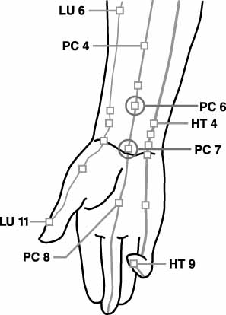
Push on the point with a finger, closed pen or narrow blunt object for up to 3 minutes.
Treats: • Nausea •Abdominal Fullness • Abdominal Pain • Arm Contraction • Arm Pain • Asthma • Cardiac Arrhythmia
• mourning sickness • Cardiac Pain • Chest Discomfort
• Chest Pain • Elbow Problems • Fever • Headache Migraine
• Hiccough Hypochondriac Region Pain • Hysteria • Insomnia
• Jaundice • Memory Impaired • Menses Irregular • Mental Disorders • Metabolic • Vomiting • Palpitations • Seizures
• Stomach Pain • Surgical Pain or Post Surgical Shock
• motion sickness

